# WinUSB Driver Installation Process for GE-Flash USB

GE-Flash USB uses the WinUSB drivers that ship natively built into Vista, Win7 and Win8. However, the GE-Flash driver directory contains the GE-FlashUSB.INF file and installer DLL’s that are required to configure the Windows drivers properly for use with the GE-Flash USB device.

## STEP 1: Install the GE-Flash 2.0 Software

First make sure you have the latest GE-Flash 2.0 software and user licensed installed and working on your machine. Install the GE-Flash software as described in the install instructions and register your license key.

## STEP 2: Connect the GE-Flash USB Programmer

Connect the GE-Flash USB programmer and Windows should recognize the device and begin searching for the driver as shown below.

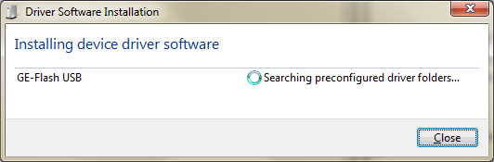

We must manually locate the driver, so cancel the search above or wait till Windows returns with the following message indicating it couldn’t find the driver.

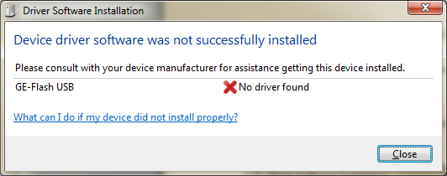

Close the dialog above and open “Control Panel” in Windows.

## STEP 3: Open Device Manager In Control Panel

Open the “Device Manager” in Control Panel and locate the **GE-Flash USB** device found in the “Other Devices” category as shown below and right click on the GE-Flash USB device and select the “Update Driver Software…” option as shown below.



## STEP 4: Locate the GE-Flash USB Driver

Next select the “**Browse my computer.*.***” option should appear as shown below. Select the “Browse my computer” option as shown below.

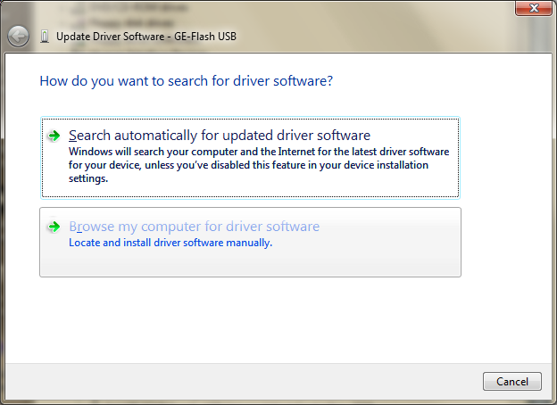

## STEP 5: Browse to the GE-Flash Driver Directory

Next we must point Windows the GE-Flash USB Driver directory located in the application install directory, normally the will be in “**C:\Program Files (x86)\Sigma Software Research\GE-Flash\GE-Flash USB Driver**” or other directory where you installed the GE-Flash application software.

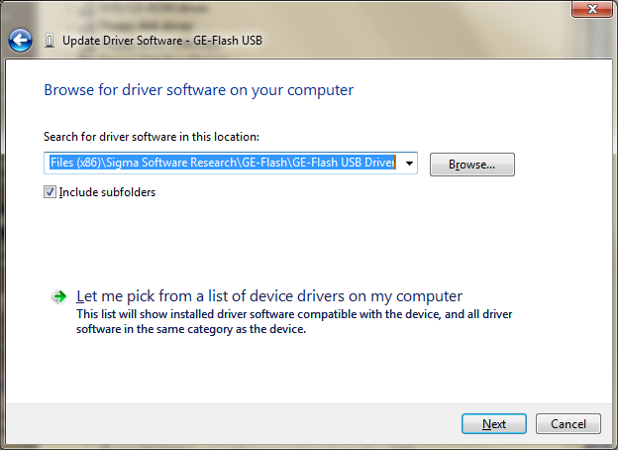

## STEP 6: Windows Security

Next Windows should prompt with the following publisher warning. Select the “**Install this driver software anyway**” option and continue.

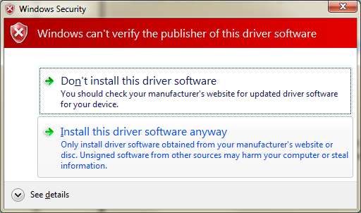

## STEP 7: Installation Complete

Windows should then continue installing the driver software and finish as shown below. If you encounter errors, please see the Drive Un-Install section and try the installation process again.

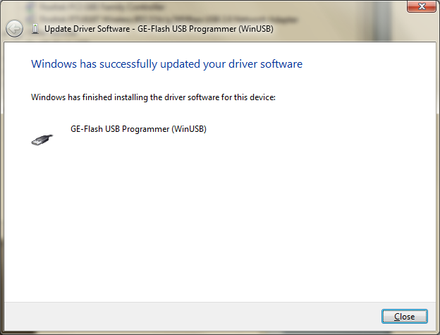

# GE-Flash USB Driver Removal Process

The GE-Flash USB driver can be completely removed via “Device Manager” in the Windows “Control Panel”.

## STEP 1: Locate the GE-Flash USB Device

Locate the “**GE-Flash USB Programmer (WinUSB)**” under the “Universal Serial Bus Controllers” section in the device manager as shown below.

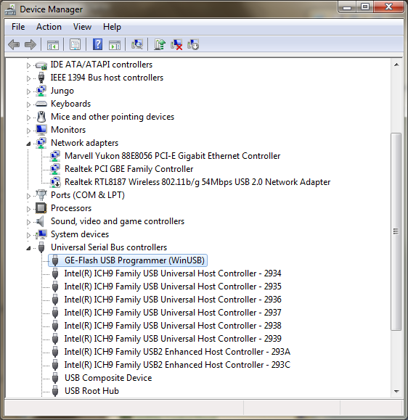

Right Click on the GE-Flash USB device and select the “**Uninstall…**” option.

## STEP 2: Confirm Uninstall

Next check the “Delete the driver software...” option for this device if you wish the completely remove the driver files and click OK to complete the driver removal. Note that if do not check the “delete driver” option, Windows will retain a copy of the INF install file in a driver cache and will automatically install the driver when the device is connected. Otherwise you’ll have to completely reinstall the driver as described in the driver installation section the next time the device is connected.

